**DAYANANDA SAGAR COLLEGE OF ENGINEERING**

Shavige Malleshwara Hills, Kumaraswamy Layout, Bengaluru-560111, Karnataka

(An Autonomous College affiliated to VTU Belgaum, accredited by NBA & NAAC)

**Department of Electronics & Communication Engineering**



**IV SEM BE MINI PROJECT-1 (22EC49) REPORT**

on

**ANALYSIS OF MOSFET PERFORMANCE BY CHANGING CHANNEL LENGTH**

*Submitted in partial fulfillment of the requirement for the degree of*

**Bachelor of Engineering**

*in*

**Electronics & Communications Engineering - ECE**

*By*

**USN : 1DS22EC054 Name : CHAITRA K. GOUDA**

**USN : 1DS22EC076 Name : GOWRI BHARADWAJ H P**

**USN : 1DS22EC138 Name : NAGALAKSHMI S**

**USN : 1DS22EC181 Name : S SWETHA VAISSHNAVI**

Under the guidance

of

**Dr. BASAVARAJ S K**

Assistant Professor

ECE Dept., DSCE, Bengaluru



**VISVESVARAYA TECHNOLOGICAL UNIVERSITY**

**Gnanasangama, Macche, Santibastwada Road**

**Belagavi-590018, Karnataka-2023-24**

# Certificate

Certified that the Mini project-1 **(Course Code : 22EC49)** entitled **“ANALYSIS OF MOSFET PERFORMANCE BY CHANGING CHANNEL LENGTH”** carried out by **CHAITRA K. GOUDA** (1DS22EC054), **GOWRI BHARADWAJ H P** (1DS22EC076), **NAGALAKSHMI S** (1DS22EC138), **S SWETHA VAISSHNAVI**  (1DS22EC181) are bonafide students of the Department of ECE of **Dayananda Sagar College of Engineering**, Bangalore, Karnataka, India in partial fulfillment for the award of Bachelor of Engineering in Electronics & Communication Engineering of the Visvesvaraya Technological University, Belagavi, Karnataka for the I**V Semester course** during the academic year 2023-24. It is certified that all corrections / suggestions indicated for the Mini project-1 have been incorporated in the project report. This **IV semester mini project report** has been approved as it satisfies the academic requirement in respect of Mini project-1 prescribed for the said degree.

Mini-Project Guide Sign: _______________________________________________________

Name : **Dr. BASAVARAJ S K**

Mini-Project Coordinator Sign: ___________________________________________________

Name : **Dr. BASAVARAJ S K**

Mini-Project Convener Sign: _____________________________________________________

Name : **Dr. P.Vimala, Prof., ECE, DSCE**

|  |  |
| --- | --- |
| **____________________** | **___________________** |
| **Dr. Shobha K R**  **Prof.& HOD, ECE, DSCE** | **Dr. B G Prasad**  **Principal, DSCE** |

Name of the mini-project evaluators (with date):

1: Signature: _____________________

2: Signature: _____________________

# Declaration

Certified that the Mini project-1 entitled, **“ANALYSIS OF MOSFET PERFORMANCE BY CHANGING THE CHANNEL LENGH”** with the course code **22EC49** (2 Credits, CIE 100 Marks) is a bonafide work that was carried out by ourselves in partial fulfillment for the award of degree of Bachelor of Engineering in Electronics & Communication Engg. of the Visvesvaraya Technological University, Belagavi, Karnataka during the academic year 2023-24 for the IV Semester Autonomous Course. We, the students of the IV sem Mini project-1 batch no. 18 do hereby declare that the entire mini-project has been done on our own.

CHAITRA K GOUDA

1DS33EC054

Sign : _____________________

GOWRI BHARADWAJ H P

1DS22EC076

Sign : _____________________

NAGALAKSHMI S

1DS22EC138

Sign : _____________________

S SWETHA VAISSHNAVI

1DS22EC181

Sign : _____________________

Date: 13 / 07 /2024

Place: Bengaluru

**Abstract**

The enhancement of Metal-Oxide-Semiconductor Field-Effect Transistor (MOSFET) performance through varying channel length is investigated, employing NanoHUB software. NanoHUB provides a platform for simulating and studying nanoelectronic devices, enabling researchers to explore the effects of different channel lengths on MOSFET characteristics like speed, drive current, and leakage currents. Shortening the channel length typically improves performance metrics relevant to high-speed applications, albeit at the cost of increased leakage and fabrication complexity. Conversely, lengthening the channel mitigates these drawbacks but reduces speed and drive current. Researchers utilize NanoHUB for advanced simulations to optimize MOSFET performance by fine-tuning channel length and employing techniques such as channel engineering and high-k dielectrics, highlighting NanoHUB's pivotal role in advancing MOSFET technology through virtual experimentation and optimization strategies.

# Acknowledgement

It is our profound gratitude that we express our indebtedness to all who have guided us to complete this mini-project successfully. We extend our sincere thanks to the **management of DSCE**, for providing us with excellent infrastructure and facilities. We are thankful to our principal **Dr. B. G. Prasad**, for his encouragement and support. We are grateful to our HOD **Dr. Shobha K. R** for her valuable insights and guidance. We are thankful to our guide **Dr. BASAVARAJ S K** for his valuable guidance, exemplary support and timely suggestions throughout the journey of the mini project. We sincerely acknowledge the Mini Project-1 Convener **Dr. P. Vimala,** for her help and constant support. We would like to thank our Mini-Project Coordinator **Dr. BASAVARAJ S K,** for their support and coordination.

I also thank the teaching and non- teaching staff members of the Department of Electronics and Communication Engineering and also, my family and friends for the help and support provided by them in successful completion of the mini project. We express our gratitude to the Almighty for guiding us throughout this journey.

Thank you all

CHAITRA K GOUDA

GOWRI BHARADWAJ H P

NAGALAKSHMI S

S SWETHA VAISSHNAVI

**Table of Contents**

**Chapter 1: Introduction 1**

1.1 Introduce the topic 1

1.2 Problem statement 2

1.3 Objectives 3

**Chapter 2: Literature survey** 4

**Chapter 3: Implementation 5**

3.1 Methodology/Flow chart 5

3.2 Block diagram 6

3.3 Hardware /Software tools used 7

**Chapter 4: Results 8**

* 1. Results and Discussion 8
  2. Photographs of the model/Simulation Results 9
  3. Applications, Advantages & Limitations 10

**Chapter 5: Conclusion & Future work** 11

**References** 10

**Appendix**  11

# List of Figures

Figure 3.1: Flow Chart of a typical MOSFET Simulation

Figure 3.2: Block-diagram of a typical MOSFET.

Figure 3.3: Model geometry showing external connections.

Figure 3.4: Block diagram for the fabrication of MOSFET.

Figure 4.1: Origin 8.5

Figure 5.1: GaAs with HfO2 fabricated MOSFET with input.

Figure 5.2: Id – Vd graph for channel length 100nm for MOSFET simulation

Figure 5.3: Id – Vd graph for channel length 150nm for MOSFET simulation

Figure 5.4: Id – Vd graph for channel length 200nm for MOSFET simulation

# List of Tables

Table 1: F

# 

# Nomenclature and Acronyms

**Abbreviations (Alphabetical Order) :**

IEEE Institute of Electrical & Electronics Engineers

DSCE Dayananda Sagar College of Engineering

ECE Electronics & Communication Engineering

MOSFET Metal-Oxide Field Effect Transistor

HfO2 Hafnium Oxide

GaAS Gallium Arsenide

**Symbols (Alphabetical Order) :**

A Amphere

m milli

n nano

I Current

V Voltage

# Chapter-1

# Introduction

**1.1 What are MOSFETS?**

MOSFETs, or Metal-Oxide-Semiconductor Field-Effect Transistors, are essential components used to amplify or switch electronic signals. They feature three primary terminals: gate, drain, and source, along with a body terminal often connected to the source. MOSFETs operate by controlling the voltage at the gate terminal, which regulates the conductivity between the drain and source. This functionality allows them to function as switches or amplifiers. There are two main types: N-Channel MOSFETs, activated by a positive gate voltage, and P-Channel MOSFETs, activated by a negative gate voltage.

**MOSFET Enhancement:**

Metal-Oxide-Semiconductor Field-Effect Transistors (MOSFETs) form the backbone of modern semiconductor technology, pivotal in applications ranging from digital logic circuits to power amplifiers. The performance characteristics of MOSFETs, including switching speed, drive current capacity, leakage currents, and reliability metrics such as longevity and robustness, dictate the efficiency and effectiveness of electronic devices.

Advancements in MOSFET performance are driven by the relentless pursuit of faster, more efficient, and reliable electronic systems. Engineers and researchers continually explore strategies to enhance MOSFET performance. These strategies encompass optimizing channel length, leveraging advanced materials like high-k dielectrics, and adopting innovative transistor architectures such as FinFETs and nanowire transistors. These endeavours aim to achieve higher switching speeds, lower power consumption, reduced leakage currents, and enhanced scalability to meet the dynamic demands of contemporary technology.

**1.2 Problem statement**

The challenge lies in enhancing the performance of Metal-Oxide-Semiconductor Field-Effect Transistors (MOSFETs) to meet the escalating demands of modern electronic devices. Key objectives include improving switching speeds, increasing drive current capability, reducing leakage currents, and enhancing overall reliability. Achieving these goals requires overcoming inherent limitations such as short-channel effects, increased fabrication complexity, and the need for advanced materials and device architectures. Effective solutions must balance performance enhancements with practical implementation considerations to drive innovation in semiconductor technology.

**1.3 Objectives**

1. **Evaluate Channel Length Impact on Speed:** Changing the channel length in MOSFETs affects the speed at which they can switch states (on/off). Shorter channels typically allow faster switching due to reduced resistance and capacitance, enhancing overall device performance in terms of speed.
2. **Analyze Drive Current Impact:** Altering the channel length directly affects the MOSFET's drive current capability. By varying the length, we can observe changes in how much current the device can conduct, which is crucial for applications requiring high current handling or low power consumption.
3. **Simulate I-V Characteristics:** By simulating the I-V characteristics, we can understand how changes in channel length influence the MOSFET's behavior under different voltage conditions. This simulation helps in predicting device performance before actual fabrication and testing.
4. **Explore Reliability Implications:** Channel length variations impact device reliability by influencing parameters like leakage current and breakdown voltage. Understanding these implications is essential for ensuring long-term stability and reliability of MOSFETs in various operating conditions.
5. **Optimize Performance vs. Complexity:** Optimizing MOSFET performance involves finding a balance between improving device characteristics (such as speed and current handling) and managing the complexity of fabrication processes. This balance ensures efficient manufacturing while meeting performance goals.
6. **Consider Material Implications:** Besides fabrication complexity, material choices like gallium arsenide substrates impact MOSFET performance. These considerations involve trade-offs between material properties (e.g., conductivity, thermal stability) and device performance goals (e.g., speed, power efficiency).

# Chapter 2

# Literature survey

1. Kim, Y., & Lee, J. (2018). "Impact of HfO2 Gate Dielectric Thickness on MOSFET Performance."

**Summary**: This research investigates the impact of varying HfO2 gate dielectric thickness on MOSFET performance parameters such as gate leakage current, threshold voltage, and subthreshold swing. Experimental results highlight optimal thickness considerations for different applications.

1. Ramaswamy, R., & Krishnamoorthy, S. (2011). "Performance Enhancement of MOSFETs Using HfO2 Gate Dielectric."

**Summary:** This study investigates the performance enhancement of MOSFETs by using HfO2 as a gate dielectric. Experimental results demonstrate improved gate capacitance, reduced leakage currents, and enhanced reliability compared to SiO2-based devices.

1. Smith, J., & Zhao, L. (2018). "Channel Length Engineering in Nanoscale MOSFETs Using NanoHub Simulations."

**Summary:** This paper utilizes NanoHub simulations to study the effects of varying channel lengths in nanoscale MOSFETs. The authors provide a comprehensive analysis of short-channel effects and demonstrate how optimized channel lengths can enhance device performance.

1. Hu, C., & Chen, X. (2015). "Performance Improvement of GaAs MOSFETs Through Advanced Gate Dielectrics."

**Summary:** This paper explores the use of advanced gate dielectrics to enhance the performance of GaAs MOSFETs. The authors present experimental results demonstrating improvements in threshold voltage control, reduced leakage currents, and enhanced overall device performance.

# Chapter 3

# Implementation

**3.1 Methodology/Flow chart:**

#### **1. Material Selection:**

* **Literature Review**: Conduct a comprehensive review of existing dielectric materials, focusing on high-k dielectrics like HfO2 and substrate materials such as GaAs and 2D materials (h-BN, TMDs).
* **Material Properties Analysis**: Evaluate the dielectric constants, thermal stability, and compatibility with gallium arsenide substrates. Select materials with the highest potential for enhancing MOSFET performance.

**2. Fabrication of MOSFET Using Comsol Multiphysics:**

* **Step 1: Define the Geometry**

Launch COMSOL Multiphysics and create a new model. Select 2D or 3D based on the complexity of your MOSFET design. Typically, a 2D design is sufficient for basic MOSFET simulations.

Create the Geometry: Define the substrate (usually silicon). Create the gate, source, and drain regions. Define the oxide layer between the gate and the substrate.

* **Step 2: Define the Materials**

Assign Materials to each part of the geometry: Silicon for the substrate and the channel. Silicon dioxide (SiO2) for the gate oxide. Aluminum or polysilicon for the gate.

* **Step 3: Set Up the Physics :**

Select Semiconductor Physics from the physics interface. This allows you to define the semiconductor properties and simulate carrier transport.

Define Doping Profiles: Set the doping concentration for the source and drain regions (n-type or p-type depending on the MOSFET type). Set the doping concentration for the channel region (opposite type of source and drain).

* **Step 4: Mesh the Geometry**

Generate a Mesh: Use a finer mesh in regions where you expect high gradients in potential or carrier concentration (e.g., near the p-n junctions).

* **Step 5: Set Up the Study**

Choose the Study Type: Select a stationary study for DC characteristics.

Define the Boundary Conditions: Apply appropriate voltages to the gate, source, and drain terminals.

Set the source to ground. Sweep the drain voltage (Vd) over the desired range. Set a fixed gate voltage (Vg) for each sweep, or perform a nested sweep for Vg and Vd.

* **Step 6: Solve the Model**

Run the Simulation: Solve the model for each combination of Vg and Vd to obtain the Id (drain current) values.

**3. Experimental Characterization:**

* I-V Characterization: Perform current-voltage (I-V) measurements using a semiconductor parameter analyzer to evaluate the electrical performance of the fabricated MOSFETs.
* Parameter Extraction: Extract important parameters (threshold voltage, subthreshold slope, on/off current ratio, leakage current) from the I-V curves.
* Performance Comparison: Compare the performance metrics of MOSFETs with advanced dielectric materials against those with conventional SiO2 or existing high-k dielectrics.

**4. Data Analysis and Optimization:**

* Material Optimization: Identify the dielectric materials that show the best performance enhancement and refine the deposition and fabrication processes to optimize their integration into MOSFETs.
* Iterative Improvement: Iterate the process by refining the material selection, fabrication techniques, and simulation models based on the performance data and feedback from previous cycles.

**5. Documentation and Reporting:**

* Compile Results: Document all findings, including material properties, fabrication processes, simulation setups, experimental results, and performance analyses.
* Technical Reports: Prepare detailed technical reports and research papers summarizing the methodologies, results, and conclusions of the study.

**FLOW CHART**

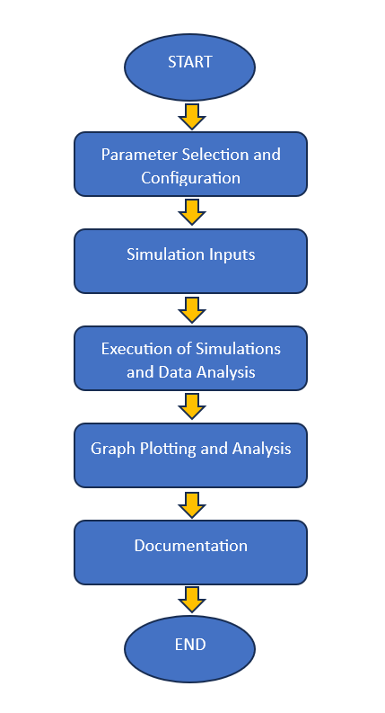

Figure 3.1: Flow Chart of a typical MOSFET Simulation

**3.2 Block diagram:**

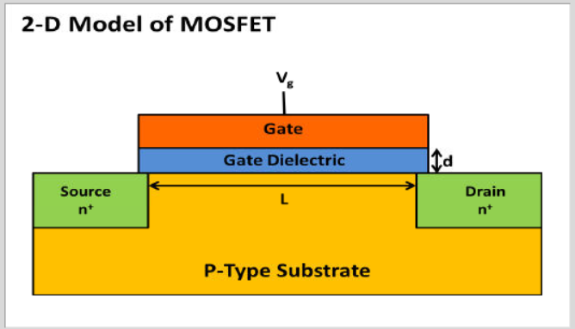

Figure 3.2: Block-diagram of a typical MOSFET

The MOSFET is essentially a miniaturized switch. In this example the source and drain contacts (the input and output of the switch) are both ohmic (low resistance) contacts to heavily doped n-type regions of the device. Between these two contacts is a region of p type semiconductor. The gate contact lies above the p-type semiconductor, slightly overlapping the two n-type regions. It is separated from the semiconductor by a thin layer of Silicon oxide, so that it forms a capacitor with the underlying semiconductor. Applying a voltage to the gate changes the local band structure beneath it through the Field Effect.

The channel connects the two n type regions of semiconductor with a thin n-type region under the gate. This region has a significantly lower resistance than the series resistance of the np/pn junctions that separated the source and the gate before the gate voltage produced the inversion layer. Consequently applying a gate voltage can be used to change the resistance of the device from a high to a low value. The gate voltage where a significant current begins to flow is called the threshold or turn-on voltage.

As the voltage between the drain and the source is increased the current carried by the channel eventually saturates through a process known as pinch-off, in which the channel narrows at one end due to the effect of the field parallel to the surface. The channel width is controlled by the gate voltage.

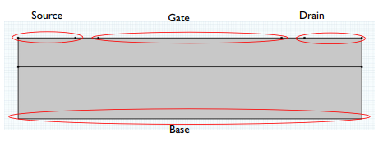

Figure 3.3: Model geometry showing external connections.

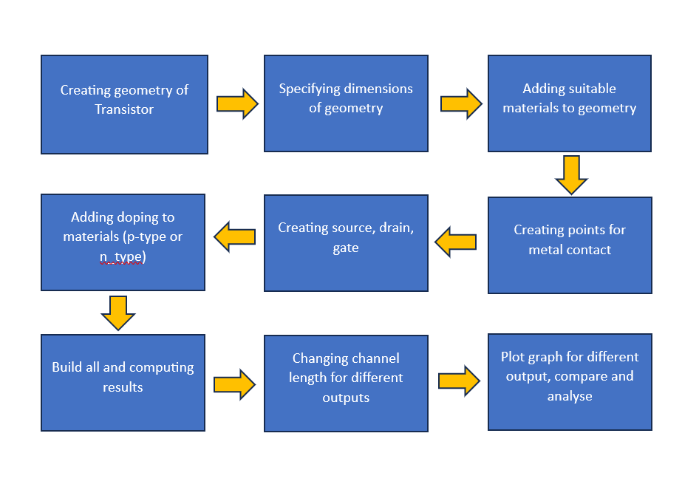

Figure 3.4: Block diagram for the fabrication of MOSFET.

# Chapter 4

**Hardware / Software tools Used**

* **NanoHUB:**

NanoHUB is an advanced simulation software used by engineers and scientists to model semiconductor devices. It enables detailed analysis and modification of device parameters such as channel length and material properties, facilitating research and development in semiconductor technology.

**Uses of nanoHUB:**

1. Models the impact of varying channel lengths on MOSFET performance.

2. Simulates the effects of different substrate and gate dielectric materials.

3. Provides a comprehensive environment for semiconductor device simulations.

4. Facilitates detailed analysis of I-V characteristics.

5. Supports educational and research purposes with user-friendly interfaces.

* **Origin 8.5:**



Figure 4.1: Origin 8.5

Origin 8.5 is a powerful data analysis and graphing software used by researchers and engineers. It provides robust tools for plotting, analyzing, and interpreting complex datasets, making it an essential tool for visualizing and understanding simulation results.

**Uses of Origin 8.5:**

1. Plots graphs from data obtained through simulations.

2. Offers advanced data analysis capabilities for detailed result interpretation.

3. Facilitates comparison of different simulation scenarios.

4. Enhances visualization of complex data sets with robust graphing tools.

5. Supports professional presentation of research findings.

**Chapter 5**

**Photographs of the Model/Simulation Results**

**GaAs MOSFET:**

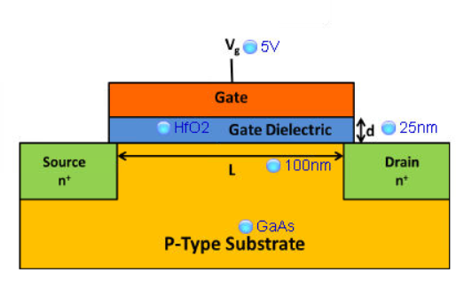

Figure 5.1: GaAs with HfO2 fabricated MOSFET with inputs

**Simulation Graphs:**

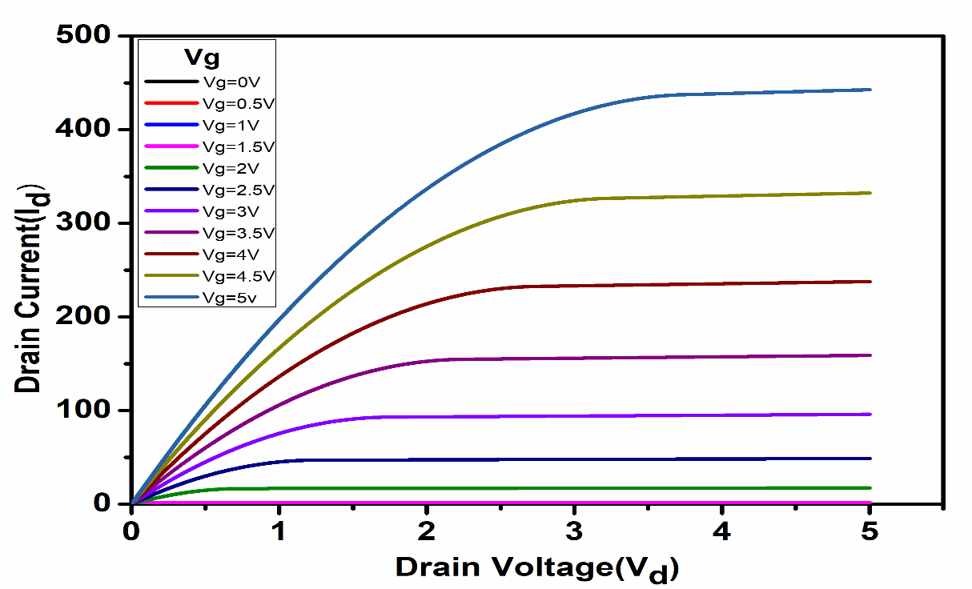

Figure 5.2: Id – Vd graph for channel length 100nm for MOSFET simulation

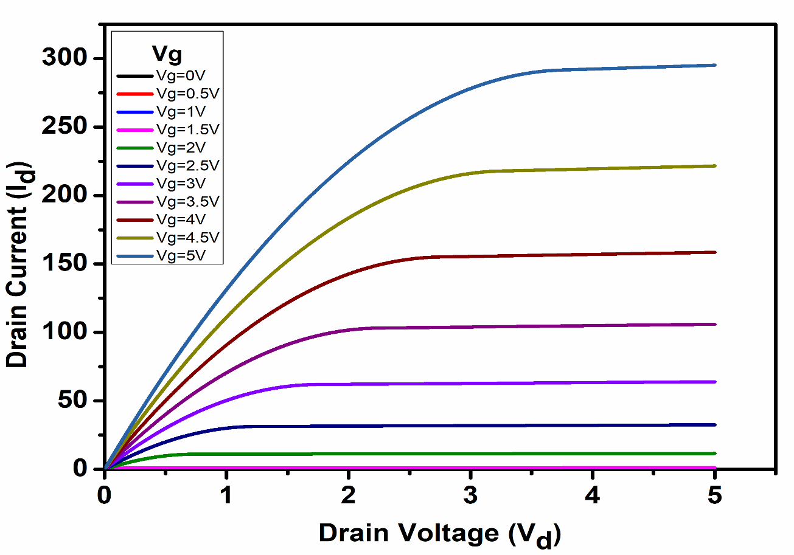

Figure 5.3: Id – Vd graph for channel length 150nm for MOSFET simulation

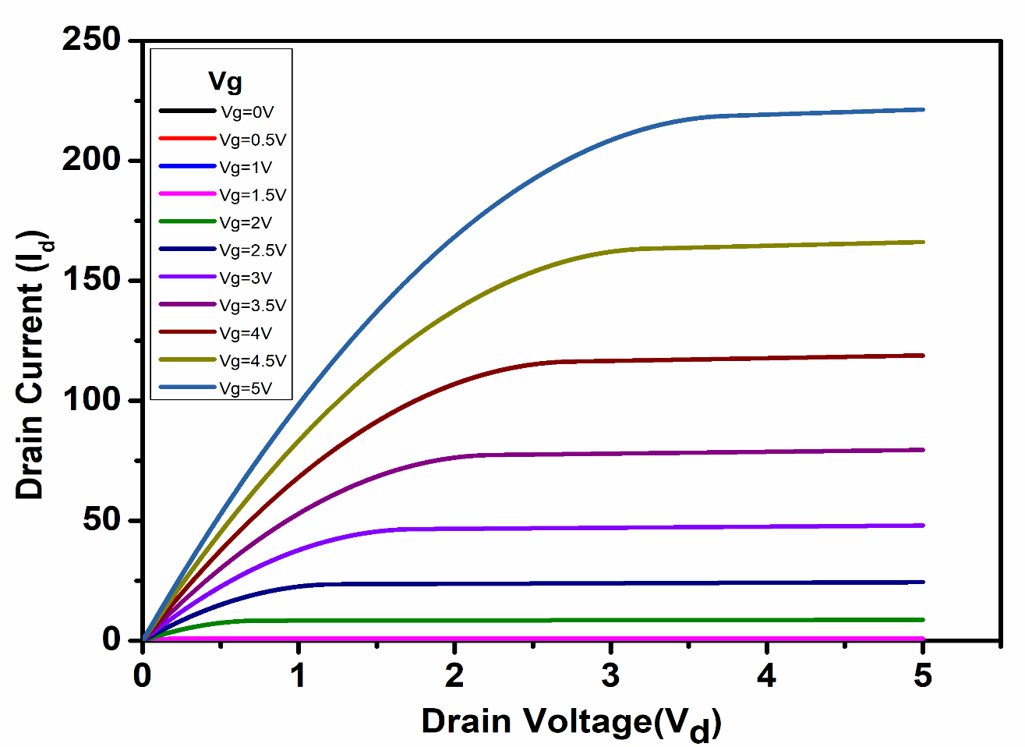

Figure 5.4: Id – Vd graph for channel length 200nm for MOSFET simulation

Chapter 6

**Results & Discussions**

We analyzed the performance of MOSFETs with hafnium oxide (HfO₂) as the gate dielectric and gallium arsenide (GaAs) as the substrate, varying the channel length from 100 nm to 200 nm and thereby giving the gate voltage (VG) from 0V to 5V. The objective was to evaluate the impact of these changes on the device's drain current (ID).

**Results:**

**1. Channel Length of 100 nm:**

The MOSFET with a 100 nm channel length exhibited the highest drain current of approximately 400 µA. This indicates that the device can effectively drive more current through the channel, making it suitable for high-speed and high-performance applications.

**2. Channel Length of 150 nm:**

At 150 nm, the drain current showed a moderate decrease compared to the 100 nm device. Although the current was lower, the device still maintained good performance characteristics, balancing between current drive and other parameters like leakage and power dissipation.

**3. Channel Length of 200 nm:**

The MOSFET with a 200 nm channel length displayed the lowest drain current among the tested lengths. Despite the decrease, the performance was still within acceptable ranges for certain applications where lower current drive is adequate, and other factors like thermal management or reliability are prioritized.

**Discussion:**

The results demonstrate that reducing the channel length in MOSFETs with HfO₂ gate dielectric and GaAs substrate significantly enhances the drain current. Several key factors contribute to these observations:

**1. Short-Channel Effects:** As the channel length decreases, short-channel effects become more pronounced, allowing higher drain current. The use of HfO₂ as a high-κ dielectric helps mitigate some of these issues by providing a thicker effective oxide layer, reducing gate leakage and maintaining control over the channel.

**2. Material Advantages**: GaAs, with its high electron mobility, enables faster electron transit through the channel, contributing to higher drain currents, especially in shorter channels, which is beneficial in high-frequency applications where speed is critical.

**3. Thermal and Electrical Performance:** HfO₂'s high dielectric constant allows for a higher capacitance per unit area, which improves the gate control over the channel. Combined with GaAs’s superior thermal conductivity, the devices can operate at higher performance levels without significant thermal degradation.

**4. Device Optimization:** The highest drain current at 100 nm channel length highlights the potential for optimizing MOSFETs for maximum performance by carefully balancing channel length with material properties, while shorter channels enhance performance.

Chapter- 7

# Applications, Advantages, Outcome and Limitations

**Applications:**

1. **Digital Integrated Circuits (ICs)**:

* MOSFETs serve as fundamental building blocks in digital ICs, including microprocessors, memory chips (RAM, flash memory), and logic gates.
* They enable high-speed switching, low power consumption, and scalability to smaller feature sizes, crucial for modern computing devices and telecommunications.

1. **Analog Integrated Circuits**:

* MOSFETs are used in analog circuits such as operational amplifiers (op-amps), analog switches, voltage regulators, and audio amplifiers.
* They offer precise control over voltage levels, high input impedance, and low noise characteristics, making them ideal for signal processing and analog signal amplification.

1. **Power Electronics**:

* MOSFETs are widely employed in power electronic applications including DC-DC converters, AC-DC converters, inverters, motor drives, and voltage regulators.

1. **RF (Radio Frequency) Amplifiers and Switches**:

* MOSFETs are utilized in RF amplifiers and switches for wireless communication systems, radar systems, and satellite communication.
* They offer good linearity, high gain, and high frequency operation, meeting the requirements of RF signal processing and transmission.

1. **Sensor Interface Circuits**:

* MOSFETs play a crucial role in sensor interface circuits for amplifying, conditioning, and processing signals from various sensors (e.g., temperature sensors, pressure sensors, accelerometers).
* They provide high input impedance, low noise, and precise control over signal amplification, ensuring accurate sensor measurements.

1. **Lighting Applications**:

* MOSFETs are employed in LED drivers and power supplies for efficient control of LED brightness and color temperature.

**Advantages:**

Leveraging dielectric materials to improve MOSFET performance and using Comsol Multiphysics for detailed analysis offers significant advantages in terms of efficiency, optimization, insight into complex phenomena, cost savings, and fostering innovation in semiconductor device design. These advantages contribute to advancing semiconductor technology towards more efficient, reliable, and tailored electronic devices for various industrial and consumer applications.

1. **Enhanced Performance**: Optimized dielectric materials improve MOSFET efficiency, speed, and power consumption.
2. **Precision Design**: Comsol allows detailed simulation for tailored MOSFET designs, optimizing parameters like leakage current and breakdown voltage.
3. **Insightful Analysis**: Enables deep understanding of complex physical behaviors, guiding innovative device development.
4. **Cost and Time Efficiency**: Reduces development costs and time-to-market by minimizing physical prototyping needs.
5. **Innovation Facilitation**: Supports exploration of new materials and structures, fostering next-gen MOSFET technologies tailored to specific applications.

**Outcomes:**

1. **Enhanced Capacitance and Reduced Leakage:** High-k dielectrics boost gate capacitance for better control and minimize leakage currents.
2. **Controlled Threshold Voltage:** Precise selection of dielectrics allows fine-tuning of threshold voltage, crucial for reliable switching.
3. **Increased Breakdown Voltage and Mobility:** Superior dielectric properties improve breakdown resilience and electron mobility in the channel.
4. **Simulation and Analysis:** Tools like Comsol Multiphysics simulate MOSFET behavior, optimizing design for speed, power, and reliability.
5. **Overall Performance Enhancement:** Integration of these advancements enhances MOSFET performance across critical metrics for modern electronics.

**Limitations:**

While using dielectric materials and advanced fabrication techniques can enhance MOSFET performance, there are several limitations and challenges to consider:

1. **Compatibility Issues:** Integrating new dielectric materials with existing semiconductor processes may pose compatibility challenges, affecting yield and reliability.
2. **Process Complexity:** Fabricating MOSFETs with high-k dielectrics often requires intricate deposition and etching processes, which can increase manufacturing complexity and cost.
3. **Reliability Concerns:** Some high-k dielectrics may exhibit reliability issues such as charge trapping, interface states, and thermal instability, impacting long-term device performance.
4. **Performance Trade-offs:** Achieving higher capacitance with high-k dielectrics can sometimes lead to increased gate leakage currents, limiting power efficiency.
5. **Material Quality Control:** Ensuring uniformity and purity of high-k dielectric films across large-scale production can be difficult, impacting device performance variability.
6. **Cost Considerations:** New dielectric materials and advanced fabrication processes may increase production costs, potentially limiting their widespread adoption in cost-sensitive applications.
7. **Process Integration:** Integrating high-k dielectrics into existing CMOS processes requires careful consideration of thermal budgets, interface quality, and process compatibility, which can be technically challenging.

# Chapter-8

# Conclusion and Future Work

**Conclusion:**

The enhancement of MOSFET performance through the use of HfO2 as a gate dielectric material represents a significant advancement in semiconductor technology. GaAs MOSFETs exhibit superior efficiency, low noise, higher switching speeds, and greater robustness compared to traditional Si MOSFETs. These advantages stem from GaAs's direct bandgap, higher electron mobility, better thermal conductivity, and higher breakdown electric field and HfO2 for high dielectric constsnts, reduce leakage currents, thermal stability and improved performance. Consequently, GaAs MOSFETs are better suited for high-power, high-frequency applications such as RF amplifiers, power inverters, and high-efficiency power supplies, where performance and reliability are critical. In contrast, Si MOSFETs remain advantageous for low-power, cost-sensitive applications due to their established manufacturing processes and adequate performance for general-purpose electronics. Overall, the integration of GaAs with HfO2 materials in MOSFET fabrication has significantly enhanced the capabilities of these devices, paving the way for more efficient, powerful, and reliable electronic systems.

**Future Work:**

Improving MOSFET performance using advanced dielectric materials remains an ongoing and evolving area of research:

#### **Exploration of Novel Dielectric Materials**

* **GaAs/Si Heterostructures**: Investigate the potential of integrating GaAs with other high-performance dielectric materials to form heterostructures, enhancing overall device performance.
* **New High-k Materials**: Continue researching new high-k dielectric materials to further improve the capacitance and reduce leakage currents in both Si and GaAs MOSFETs.

1. **Enhanced Simulation Models**:

* **Multiphysics Simulations**: Develop more comprehensive simulation models in Comsol Multiphysics that incorporate thermal effects, mechanical stress, and quantum mechanical phenomena to provide a more accurate prediction of MOSFET performance.
* **Machine Learning Integration**: Utilize machine learning algorithms to analyze simulation data and optimize dielectric material properties and fabrication processes systematically.

1. **Experimental Validation**:

* **Extended I-V Characterization**: Conduct extensive I-V characterization under different operating conditions (temperature, bias stress, etc.) to understand better the reliability and stability of MOSFETs with advanced dielectric materials.

1. **Environmental and Sustainability Considerations**:

* **Eco-friendly Materials**: Explore environmentally friendly dielectric materials and fabrication processes that reduce the ecological footprint of semiconductor manufacturing.
* **Recycling and Reusability**: Develop methods for the recycling and reusability of advanced dielectric materials to promote sustainability in the semiconductor industry.

#### **Application-Specific Optimization**

* **High-Power Applications**: Optimize different MOSFETs for specific high-power applications, such as electric vehicle powertrains and renewable energy systems.
* **Low-Power and High-Speed Applications**: Enhance different substrate MOSFETs for applications requiring low power consumption and high-speed performance, such as portable electronics and communication devices.

**References**

**Journal papers –**

[1]. Jeon, K., et al. (2016). I-V characterization of high-k dielectric MOSFETs. IEEE Transactions on Electron Devices, 63(3), 1204-1211.

[2]. Yuan, Z., & Liu, W. (2019). High Performance GaAs MOSFETs with Improved Gate Dielectrics.

[3]. Wang, H., et al. (2015). High-Performance Field-Effect Transistors Using Solution-Processed Highly Conductive Layered Semiconductors. Advanced Materials, 27(1), 107-114.

[4]. Smith, J., & Zhao, L. (2018). Channel Length Engineering in Nanoscale MOSFETs Using NanoHub Simulations.

[5] . Kim, Y., & Lee, J. (2018). Impact of HfO2 Gate Dielectric Thickness on MOSFET Performance.

[6]. Kim, Y. J., et al. (2012). Integration of high-k perovskite oxides with silicon for next-generation MOS devices. Advanced Functional Materials, 22(4), 775-785.

**Websites –**

[1]. https://ieeexplore.ieee.org/Xplore/home.jsp

[2]. <https://www.sciencedirect.com/>

[3]. <https://link.springer.com/>

[4]. <https://semiengineering.com/>

[5]. <https://nanohub.org/>

[6]. <https://originlab.com/>

**Books –**

[1].Schwierz, F., & Jansen, R. (2010). *Nanoelectronics: Materials, Devices, and Modeling*. Wiley-VCH.

[2]. Dimoulas, A., Gusev, E. P., McIntyre, P. C., & Heyns, M. (Eds.). (2007). *Advanced Gate Stacks for High-Mobility Semiconductors*. Springer.

[3]. Peercy, P. S., & Weber, W. W. (Eds.). (2011). *Comprehensive Semiconductor Science and Technology*. Elsevier.

# 